TASK:

Create a dashboard for security related metrics

Csv data:

timestamp,incident_id,incident_type,severity,status,vulnerability_id,vuln_type,vuln_severity,vuln_status,compliance_area,compliance_status,user_id,login_success,login_time,alert_id,alert_type,alert_severity

2025-09-10T10:00:00Z,INC001,Malware,High,Open,VULN001,SQL Injection,Critical,Open,PCI-DSS,Non-Compliant,user001,True,2025-09-10T09:55:00Z,ALERT001,Unauthorized Access,High

2025-09-10T11:00:00Z,INC002,Phishing,Medium,Resolved,VULN002,Cross-site Scripting,Medium,Resolved,ISO27001,Compliant,user002,False,2025-09-10T10:58:00Z,ALERT002,Brute Force Attempt,Critical

2025-09-10T12:00:00Z,INC003,Data Leak,High,Open,VULN003,Unpatched Software,Critical,Open,GDPR,Non-Compliant,user003,True,2025-09-10T11:59:00Z,ALERT003,Privilege Escalation,Medium

2025-09-10T13:00:00Z,INC004,Malware,Low,Open,VULN004,Weak Password Policy,Low,Open,NIST,Compliant,user004,True,2025-09-10T12:59:00Z,ALERT004,Malware Behavior,High

2025-09-10T14:00:00Z,INC005,Phishing,Critical,Resolved,VULN005,Open Ports,Critical,Resolved,PCI-DSS,Compliant,user005,False,2025-09-10T13:55:00Z,ALERT005,Data Exfiltration,Critical

1. Panel 1 - Security Incidents Overview

Screenshots:

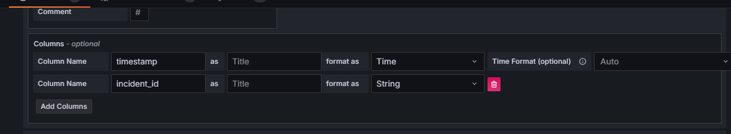

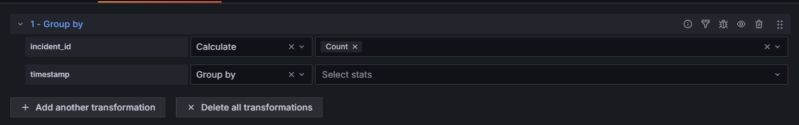

* To display a time series graph we need a time field and also a number field .
* Here timestamp is time but incident id is string.
* So timestamp can be used in a transformation of groupby.
* Then only we can use calculate for incident_id ..to treat it as number
* So by giving count to incident_id by using calculate: It will count the no: of incidents on that time period.
* It shows in this particular time how many incidents happened.

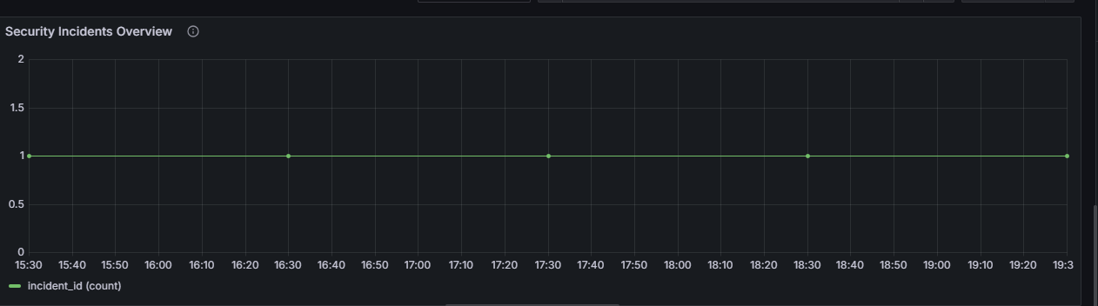

1. Panel 2 - Vulnerability Status Overview

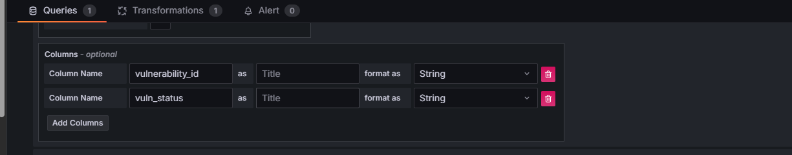

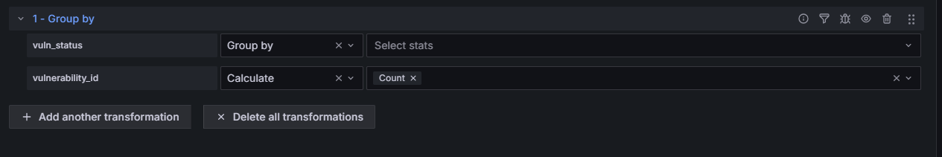

* So here also vulnerability_id should treat as number to count the vulnerability count.
* So groupby should be used to perform count function in vulnerability_id
* So Groupby used in vuln_status.
* And calculate -> count performed in vulnerability_id to calculate the count.
* It will displays the count of the open and resolved vulnerabilities in your system.

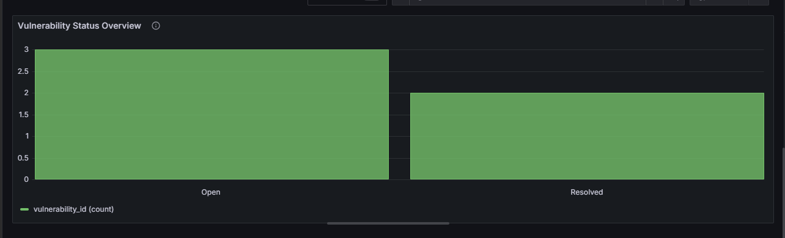

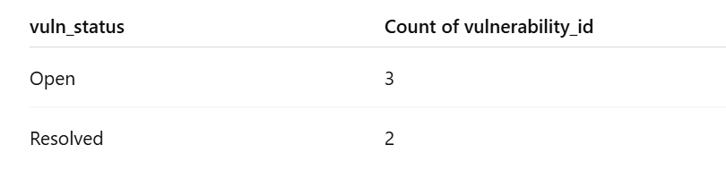

1. Panel 3 - Compliance Status Overview

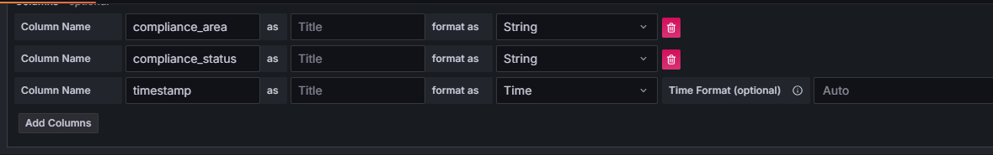

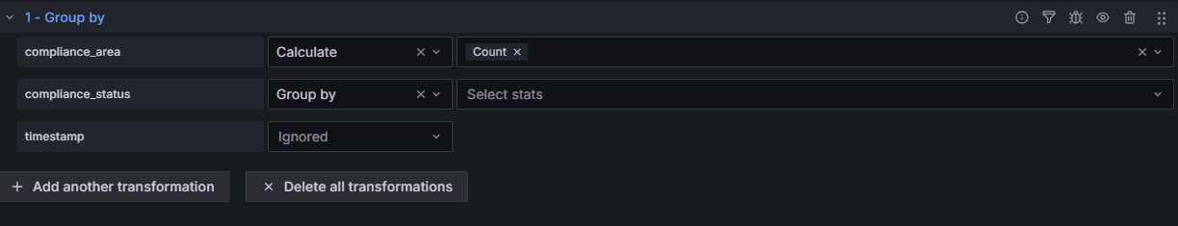

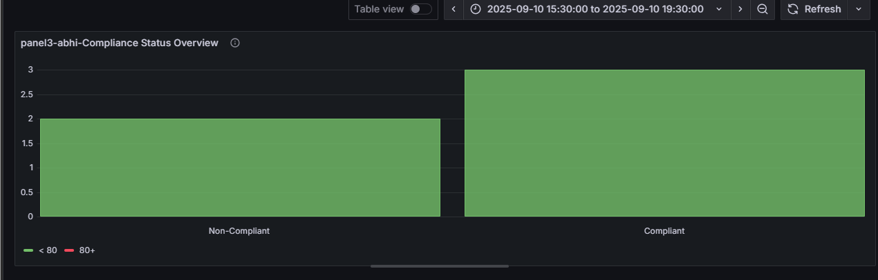

1. Panel 4 – Access & Authentication Overview

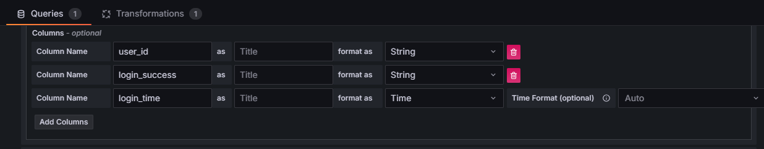

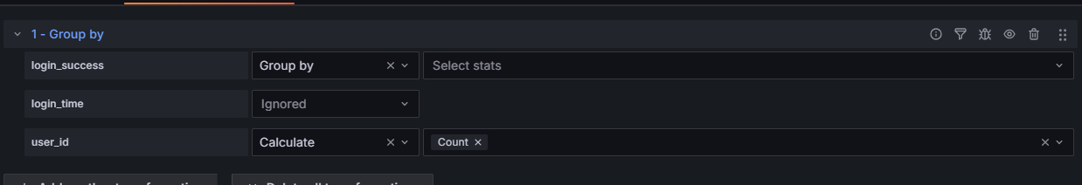

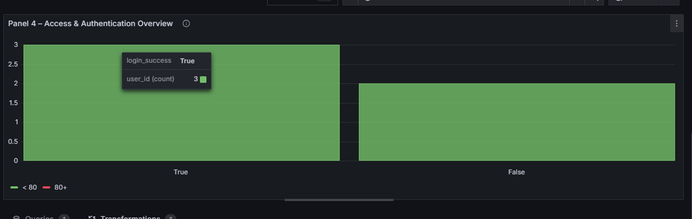

1. Panel 5 – SIEM (Security Alerts) Dashboard

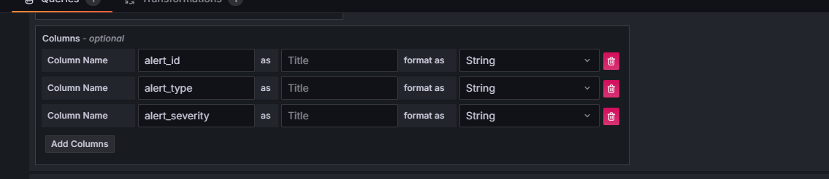

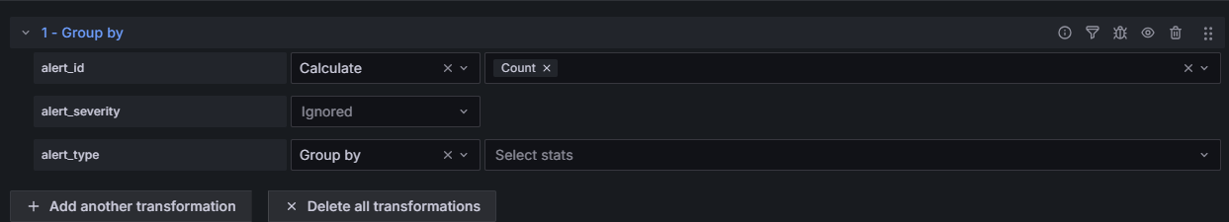

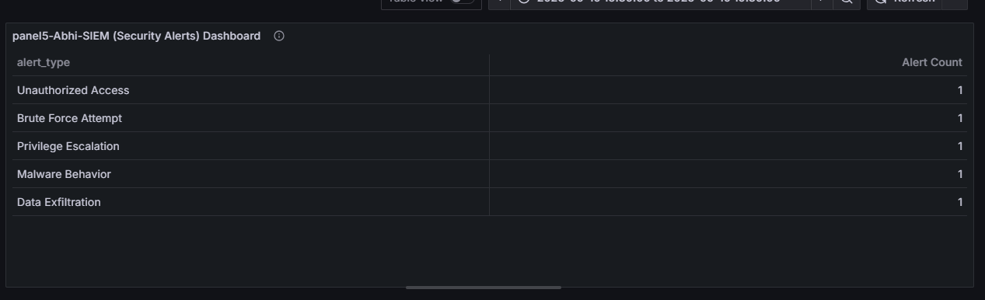

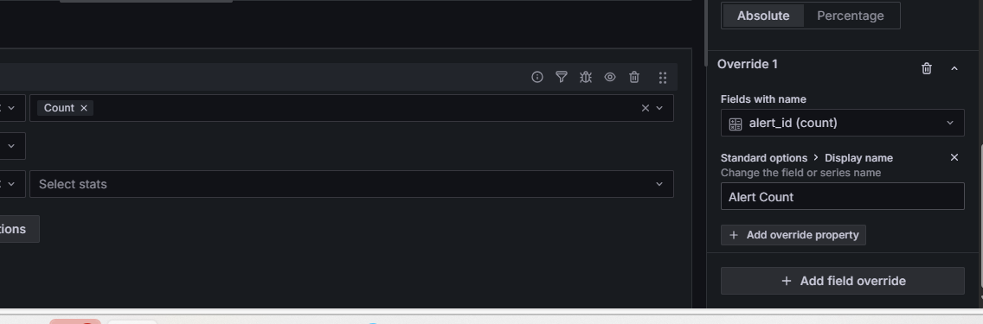

1. Heading:

<div style="color: black; background-color: white; padding: 10px; text-align: center; border-bottom: 2px solid #E0E0E0;">

<h1>Security Related Metrics Dashboard</h1>

</div>

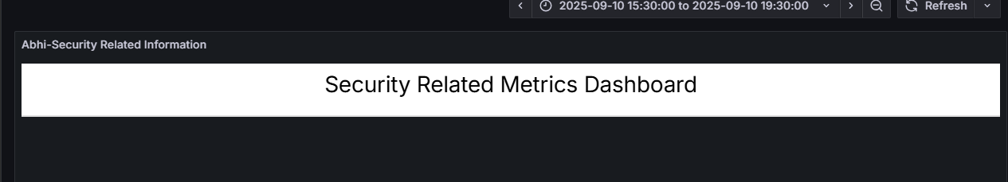

1. Dashboard:

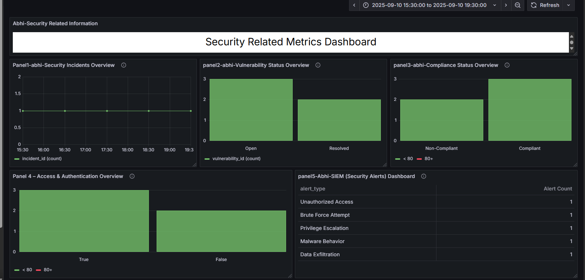

1. Took backup:

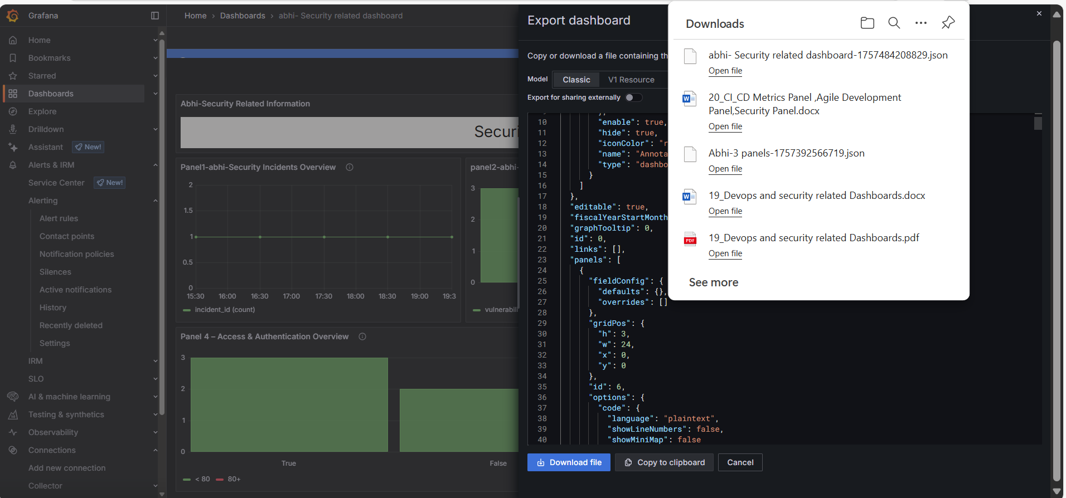

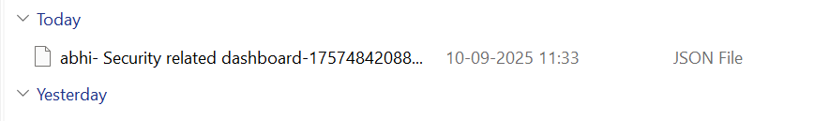

1. Github link of backup jsonfile of this dashboard:

[UST-Observability/Json_backup_files/abhi- Security related dashboard-1757484208829.json at main · Abhiramikannan/UST-Observability](https://github.com/Abhiramikannan/UST-Observability/blob/main/Json_backup_files/abhi-%20Security%20related%20dashboard-1757484208829.json)